1. Introduction **(5%)**

Introduce the background of the project. Illustrate any assumptions made, for example, the lighting conditions you need to deal with in an orchard environment. Clearly show the aim and objectives of this project and discuss the challenges.

2. Related works **(10%) 相关工作**

Conduct a short literature review on methods relevant to apple counting. For example, if algorithms proposed in prior works on berry detection/counting are deemed applicable to apple counting, you may include a critical review of these as well.

In later sections, you may use this literature review to assist with justification of your methodology as well as with discussing its capabilities and limitations. You will be assessed on the breadth and depth of the review.

对与苹果计数有关的方法进行简短的文献回顾。例如，如果以前关于浆果检测/计数的工作中提出的算法被认为适用于苹果计数，你也可以包括对这些算法的严格审查。

在后面的章节中，你可以利用这一文献综述来帮助证明你的方法，并讨论其能力和限制。你将根据评论的广度和深度进行评估。

3. Data acquisition and datasets **(10%)**

Note that you are not expected to carry out any physical data capture experiment. Instead, illustrate the types of image sensors/imaging systems that can be employed to achieve effective apple counting in a real-world application. Describe the process of data acquisition using the sensor(s) of your choice.

Describe the dataset(s) you employed in this project. Discuss data quality, variability, appropriateness for use in this project, and briefly how they were used in this project with reason.

请注意，你不需要进行任何物理数据采集实验。相反，请说明可以采用哪些类型的图像传感器/成像系统，以便在现实世界的应用中实现有效的苹果计数。描述使用你选择的传感器进行数据采集的过程。

描述你在这个项目中使用的数据集。讨论数据的质量、变异性、在本项目中使用的适当性，并简要说明在本项目中如何使用这些数据的原因。

4. Methodology **(30% in total, 15% per approach), (or for any student completing this assignment individually, 25% in total)**

Present the approach(es) you proposed. Show technical breadth and depth. Justify the use of specific algorithms. Use flowcharts to illustrate the process if applicable. You are welcome to use any image processing/machine learning approach, however basic it may seem, as long as you can justify it well, e.g. why do you think the proposed approach can deal with the challenges identified in Section 1 and 2. Refer to Requirement 4 for more information.

介绍你提出的方法。展示技术的广度和深度。证明具体算法的使用是合理的。如果适用的话，使用流程图来说明这个过程。我们欢迎你使用任何图像处理/机器学习方法，无论它看起来多么基本，只要你能很好地证明它，例如，为什么你认为建议的方法可以处理第1和第2节中确定的挑战。更多信息请参考要求4。

4.1 Approach A

**4.2 Approach B**

In this section only methodology is explained, for further process designing reasons, please see section 5. Experiment and Implementation.

For classical approach, we use a method as below:

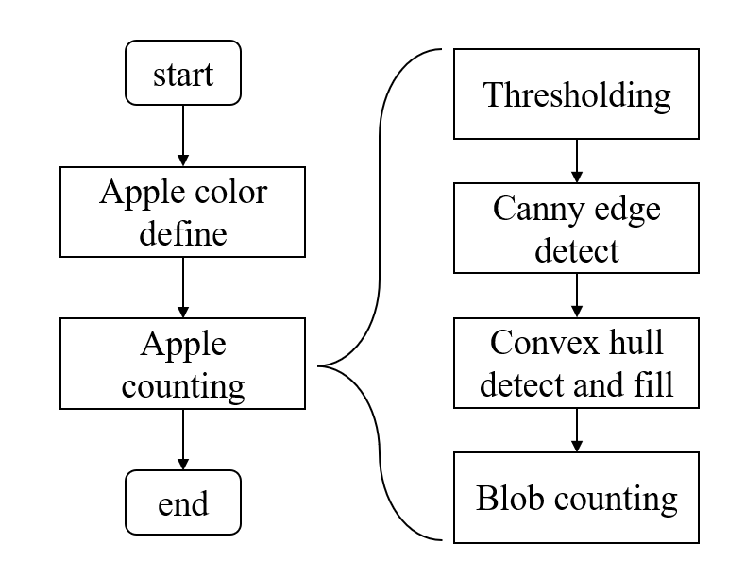

Figure 1: Classical method overall flow chart

**4.2.1 Apple color define:**

In this step, we distinguish whether there are red or green apples in the image. This step exists because we use adaptive colour thresholding based on image extreme pixel values for apple detection in a subsequent step to ensure the sensitivity of detection, and the adaptive thresholding will give the wrong answer if we do not first determine whether there are apples of a certain colour in the figure.

We use fixed color threshold to do this step. For red, use hue channel from HSV color space. For green, use Cb channel from YCrCb color space. The threshold is manually adjusted based on our observation to the images in the dataset. The thresholds are tuned to be strict to make sure that there are less false judgements (only determine if there are red and/or green apples, not to detect them all).

If red apple detected, call the red apple counting function. If green apple detected, call green apple counting function. If both kind of apple exists, call both counting function and combine their results.

**Process detail:**

1. Read image in 3 channel RGB format (8-bit for each channel).
2. Convert image to HSV and YCrCb format, take the H and Cb channel data. Use H for red and use Cb for green.
3. Use threshold to detect if there is apple:
   1. Red detection: Find $min$ and $max$ value in the H channel data, if $max>170$ and $min<15$, we consider there is red apple.
   2. Green detection: Find min value in the Cb channel data, if min < 10, we consider there is green apple.

**4.2.2 Apple counting**

In this step we perform a count of the number of apples. The apples are first segmented from background with a adaptive colour threshold, then the apples are separated from each other by canny edges, then convex detection and filling is performed, and finally the number of colour blocks is counted.

1. **Thresholding**

We use different color spaces for red and green in thresholding. In this step we would create a mask which segment apples from the background.

1. Green:
   1. Find $min$ and $max$ value in Cb channel of YCrCb color space.
   2. Calculate Cb value range $r = max-min$
   3. Calculate adaptive threshold $t = min+r×0.48$, the weight for range is manually adjusted.
   4. Generate grayscale mask with threshold $t$, original pixel Cb values below the threshold are set to white (255), and those above the threshold are set to black (0).
2. Red: For red, we use double thresholds.
   1. Do thresholding in HSV color space:
      1. Find $H_{min}$, $H_{max}$ in H channel of the image and calculate H value range $r_{H}=H_{max}-H_{min}$.
      2. Calculate adaptive thresholds for HSV color space. Apple red is at both ends of the H axis, so we have two thresholds: $t_{Hmax} = H_{max}-r_{H}×0.1$, and $t_{Hmin}= H_{min}+r_{H}×0.1$*.*
      3. Generate greyscale mask $mask_{H}$ with thresholds $t_{Hmin},{ t}_{Hmax}$. All pixels whose H value is not within the range of $\left[0,t_{Hmin}\right]∪\left[t_{Hmax},255\right]$ are set to black (0) and set other pixels to white (255).
   2. Do thresholding in RGB color space:
      1. Compute R channel percentage $p_{R}$ in RGB color space.
      2. Calculate adaptive threshold $t_{p_{R}}$ for R channel percentage. Find min value $min_{p_{R}}$ and max value $max_{p_{R}}$, and take $t_{p_{R}}=max_{p_{R}}-\left(max_{p_{R}}-min_{p_{R}}\right)×0.5$ as adaptive threshold.
      3. Generate greyscale mask $mask_{R}$ with pixel’s $p_{R}$ and red channel value. All pixels whose R channel value < 70 or $p_{R}<t_{p_{R}}$ are set to black (0) and set other pixels to white (255).
   3. Combine thresholding results from both color spaces: do bitwise and between $mask_{H}$ and $mask_{R}$. After this step only pixels which are within both HSV threshold and RGB threshold are marked as white (255), and other pixels are black (0).
3. Reduce noise by apply an opening operation with an 8×8 kernel.

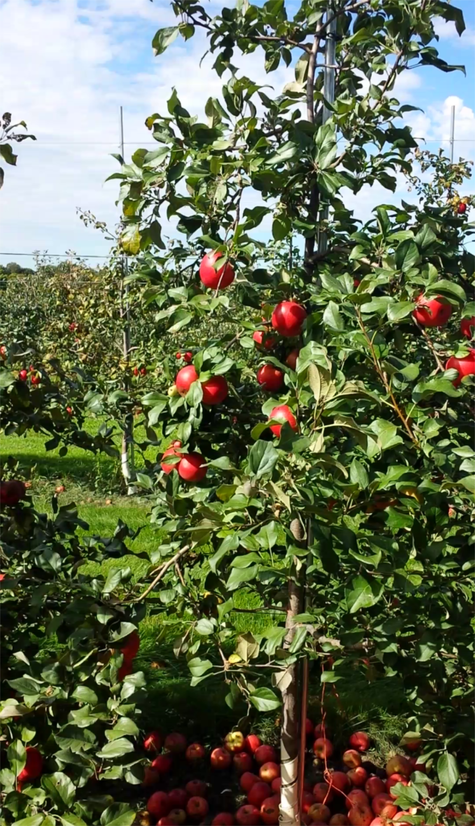 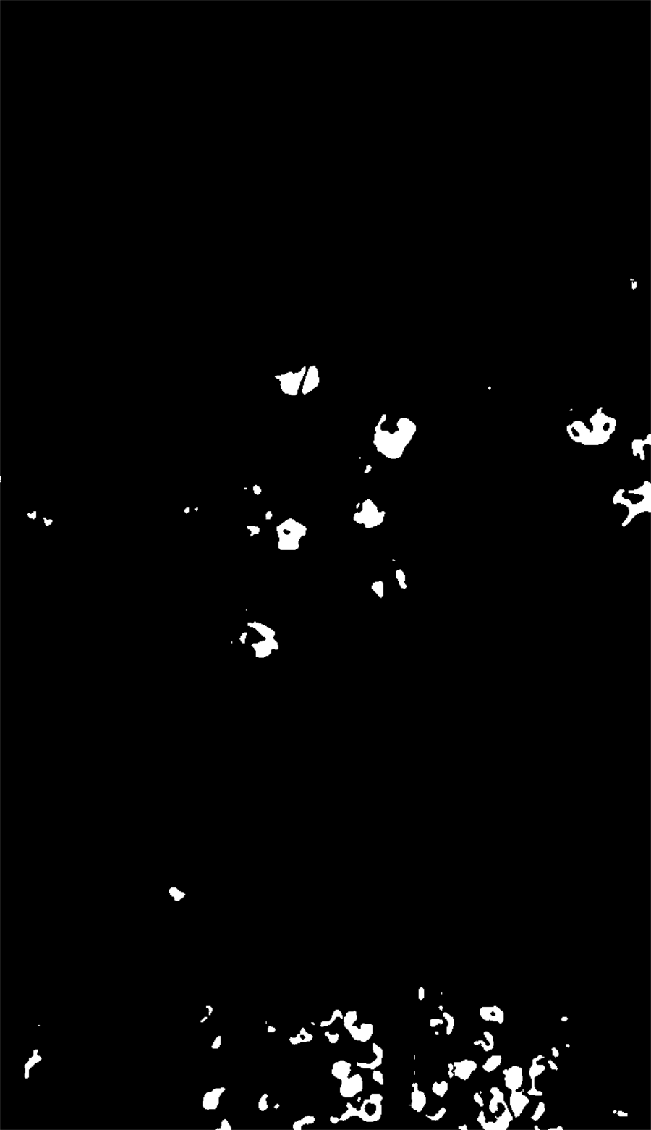

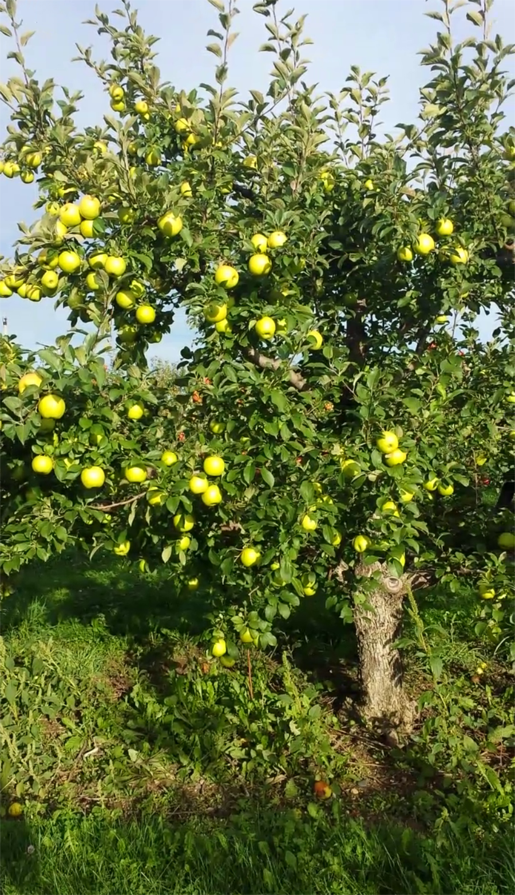 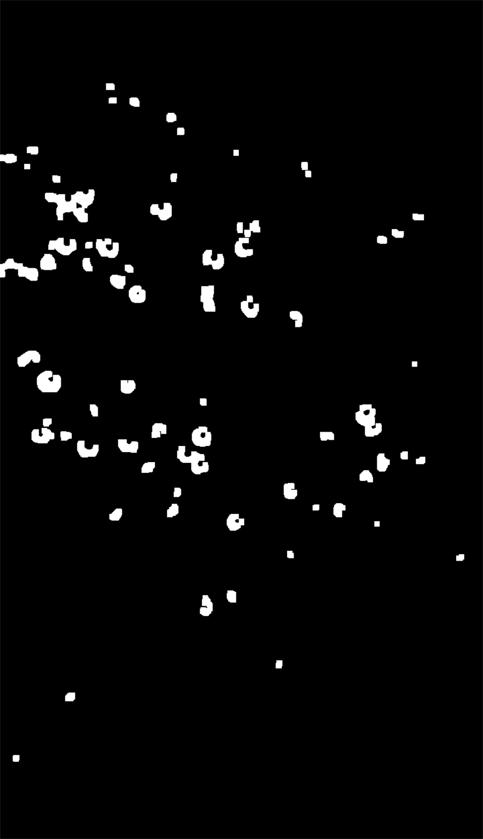

Figure 2: Thresholding Results

1. **Canny edge detect**

We use Canny edges to divide overlapped apples.

1. Use mask from previous step, extract apples from original RGB image.
2. Convert segmented apples to greyscale.
3. Apply median filter to reduce noises in Canny edge detection.
4. Calculate Canny edge.
5. Use Canny edge to separate overlapped apples by adding the black edge line to the apple blobs.

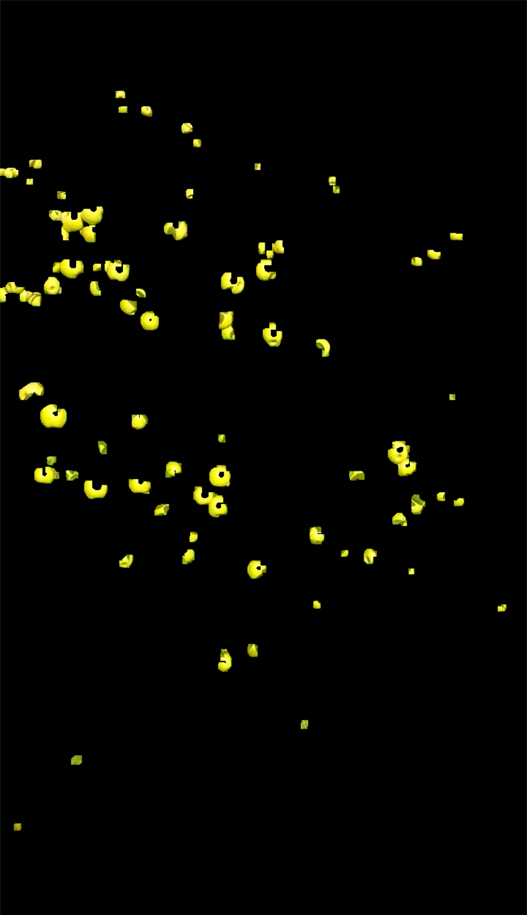 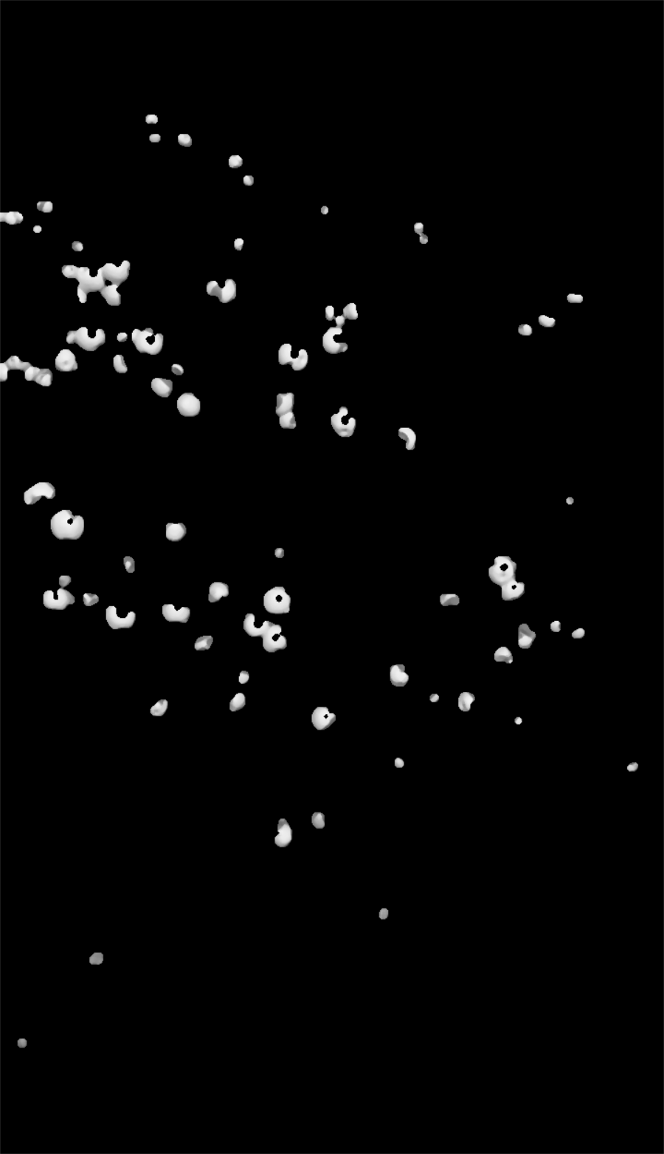 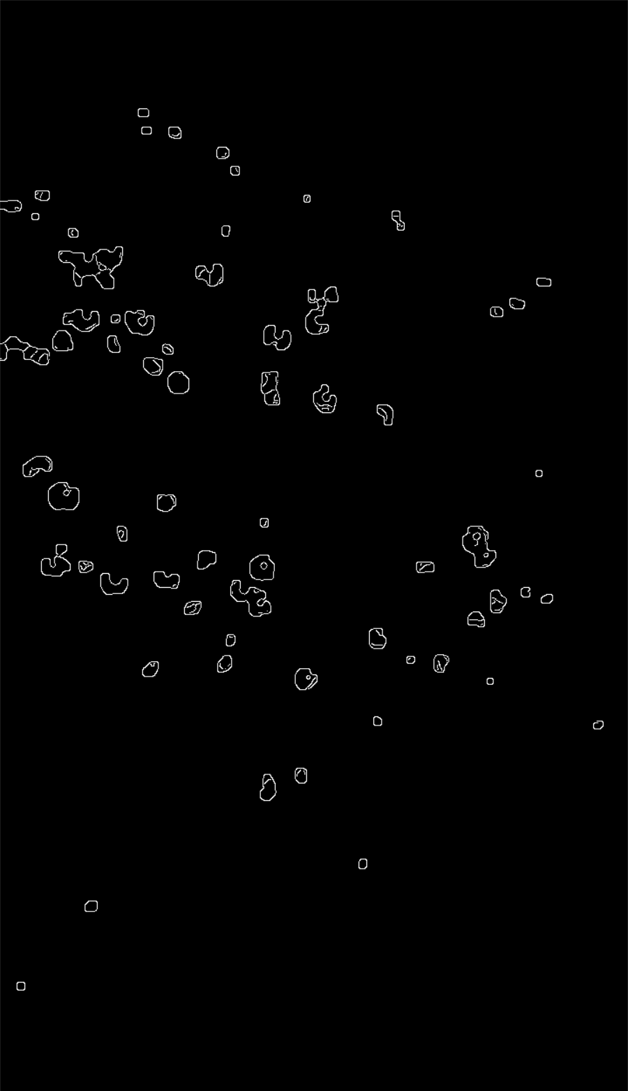

(1) (2) (3)

Figure 3: Canny edge detection. 3-1: Segmented apples. 3-2: Converted to greyscale and applied median filter. 3-3: Canny edge detection result.

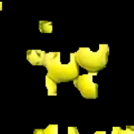 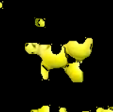

Figure 4: Result of dividing overlapping apples. Apples separated by adding black edges on apple blobs.

1. **Convex hulls detect and fill**

We filter tiny blobs and readjust blob shape in this step.

1. Convert divided apple image (from previous step) to greyscale.
2. Apply open to the greyscale image, to make the interval clear enough.
3. Detect all contours in the greyscale image
4. Fill all contours whose perimeter is greater than 8.
5. Apply close and erode to remove noises.

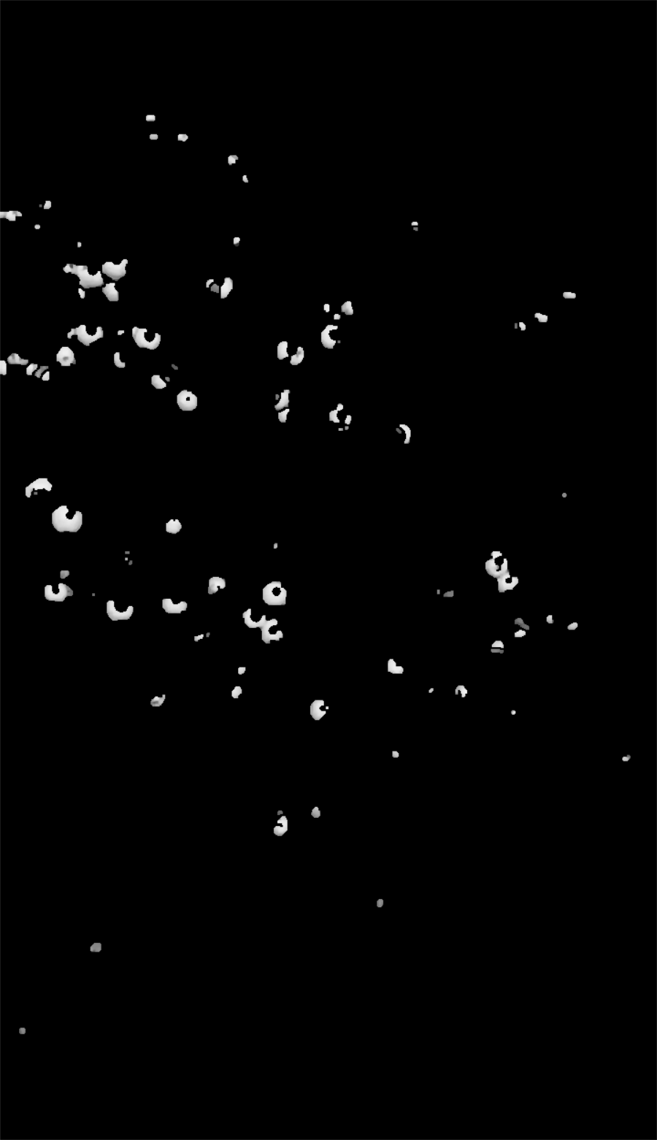 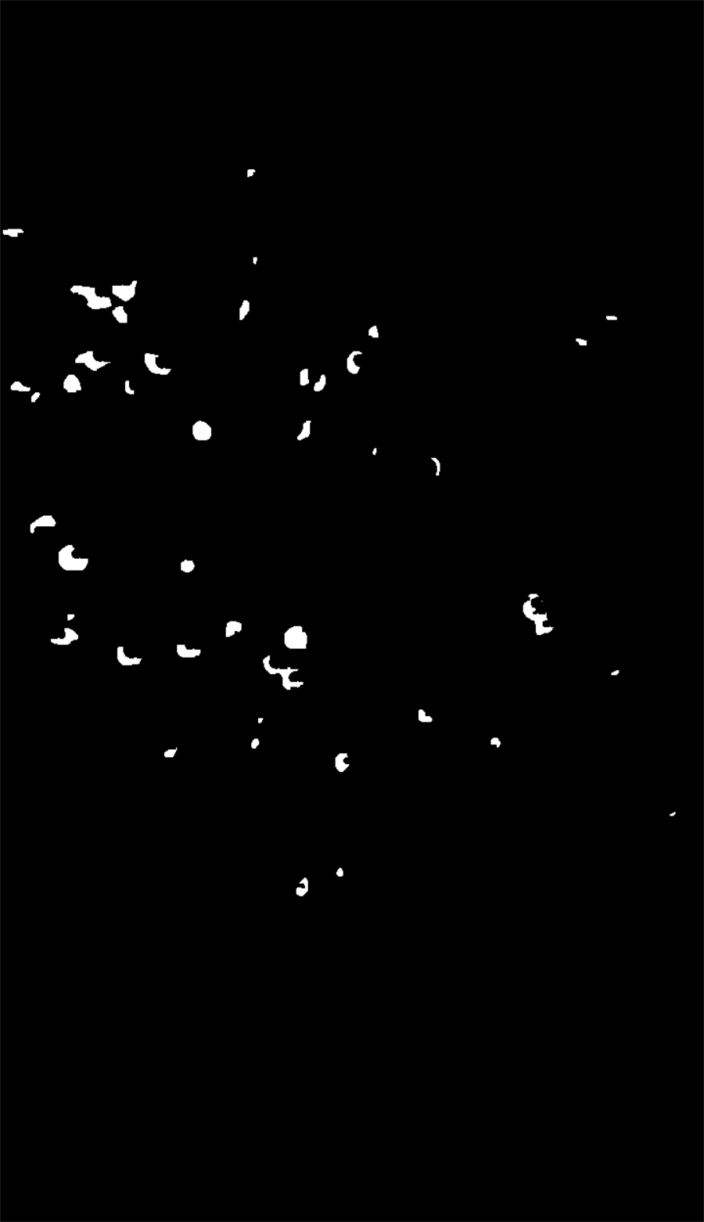

(1) (2)

Figure 5: Before (1) and after (2) contour fill. Tiny blobs filtered.

1. **Blob counting**

Count connected areas. In ideal, each connected area represents an apple, and the centre of the area is the centre of the apple.

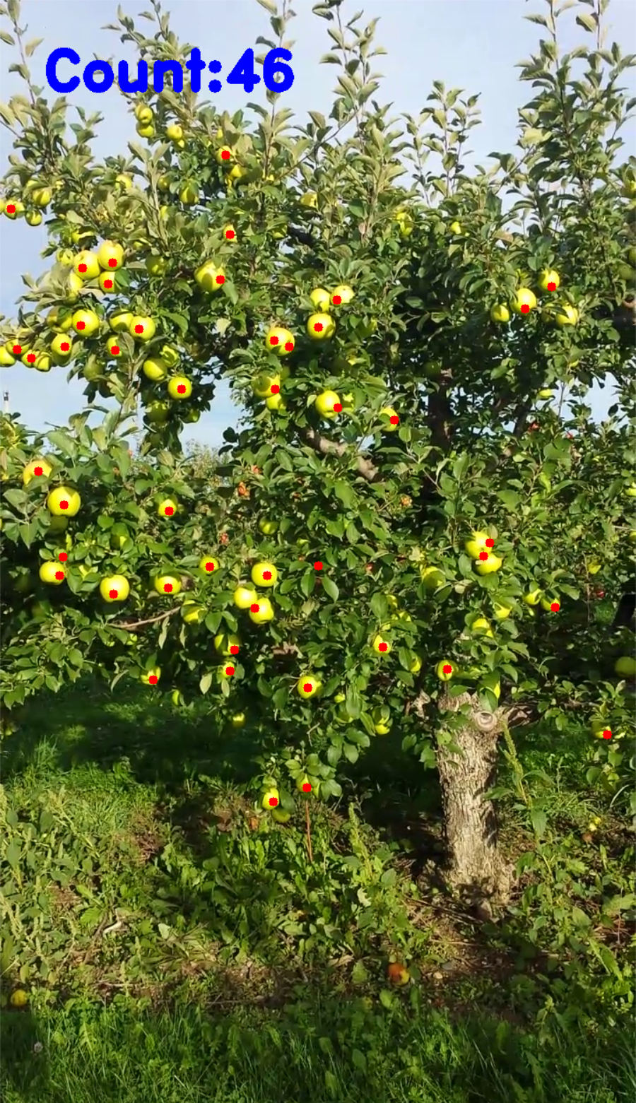 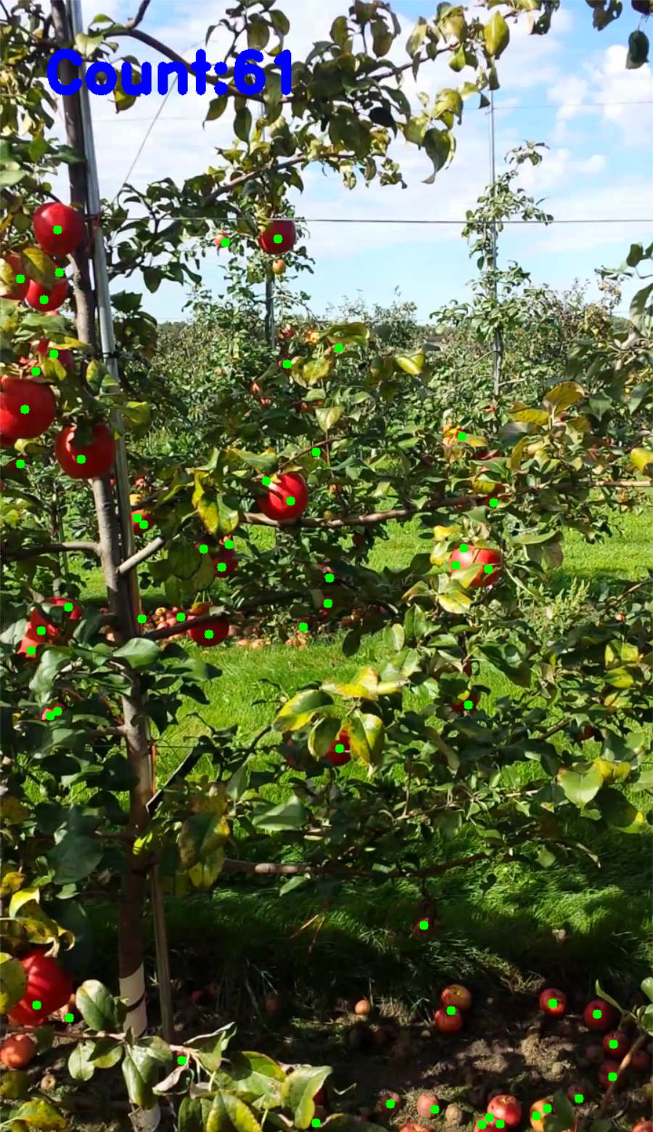

Figure 6: Classical approach result.

5. Experiment and Implementation **(15%), (or for any student completing this assignment individually, 20% in total)**

Demonstrate that you are able to implement the proposed approaches (introduced in Section 3) using Python programming. Describe the Python IDE/platform/hardware used, core python packages used, how you trained your machine learning model(s) if applicable, parameter tuning/optimisation of key algorithms if applicable. For example, if you used manual thresholding for binarization, explain how you chose an appropriate threshold. If you used deep learning models, explain how you loaded your images and ground truth data; how you split the data for training, validation and testing; and justify the training epochs used. Note that you are not expected to describe each line of your code here. Use flowcharts, diagrams and/or pseudocode where applicable.

证明你能够使用Python编程实现所提出的方法（在第3节中介绍）。描述所使用的Python IDE/平台/硬件，所使用的核心Python包，如果适用，你是如何训练你的机器学习模型的，如果适用，对关键算法进行参数调整/优化。例如，如果你使用手动阈值来进行二进制化，请解释你是如何选择一个合适的阈值。如果你使用了深度学习模型，请解释你是如何加载你的图像和地面真实数据的；你是如何为训练、验证和测试分割数据的；并证明所使用的训练纪元的合理性。请注意，你不需要在这里描述你的每一行代码。适当时使用流程图、图表和/或伪代码。

**5.2 Classical Approach Implementation and Designing Details**

**5.2.1 Packages and Environment**

Use python 3.915 with OpenCV 4.6.0

**5.2.2 Implementation**

**For the** **complete and detailed implementation, please see GitHub repository:**

<https://github.com/Vehshanaan/MV/blob/main/Codes/ClassicalProcess.py>

The correspondence between the operations in the algorithm and the function in the CV is shown below:

|  |  |
| --- | --- |
| **Operations:** | **OpenCV Function:** |
| Read/Plot image | cv2.imread(), cv2.imshow() |
| Convert color | cv2.cvtColor() |
| Thresholding | cv2.threshold |
| Bitwise operation | cv2.bitwise_and(), cv2.bitwise_or() … |
| Median blur | cv2.medianBlur() |
| Open/Close | cv2.morphologyEx() |
| Erode/Dilate | cv2.erode(), cv2.dilate() |
| Canny edge detect | cv2.Canny() |
| Convex detect and fill | cv2.findContours(), cv2.convexHull(),  cv2.fillConvexPoly() |
| Connected area counting | cv2. connectedComponentsWithStats() |

Table 1: Python cv2 function used

**5.2.3 Parameter Detail**

Many parameters included in the algorithm processing, e.g. morphology kernel size, threshold for color, etc.

We follow a common principle in the tuning process, which is: tune parameters step by step. Tune up parameters for one step, get the desired result, then continue to next step.

Listing all parameters would lost focus, so only key parameters are listed, and for all detailed parameters please see [GitHub repository](https://github.com/Vehshanaan/MV/blob/main/Codes/ClassicalProcess.py).

1. **Color Thresholds: Based on experience**

We didn’t find a proper way to derive a completely objective color threshold. So, we tuned color thresholds by observing the thresholding results and apple pixel value ranges.

When doing the color defining (4.2.1), we use fixed strict thresholds.

When doing the segmentation (4.2.2), we use adaptive thresholds. Fixed color threshold is not robust enough for different illumination conditions across the whole dataset. Weights in adaptive threshold calculation are manually adjusted.

* 1. **Green:** Using YCrCb color space to do thresholding, in Cb channel, green apples have low pixel value.

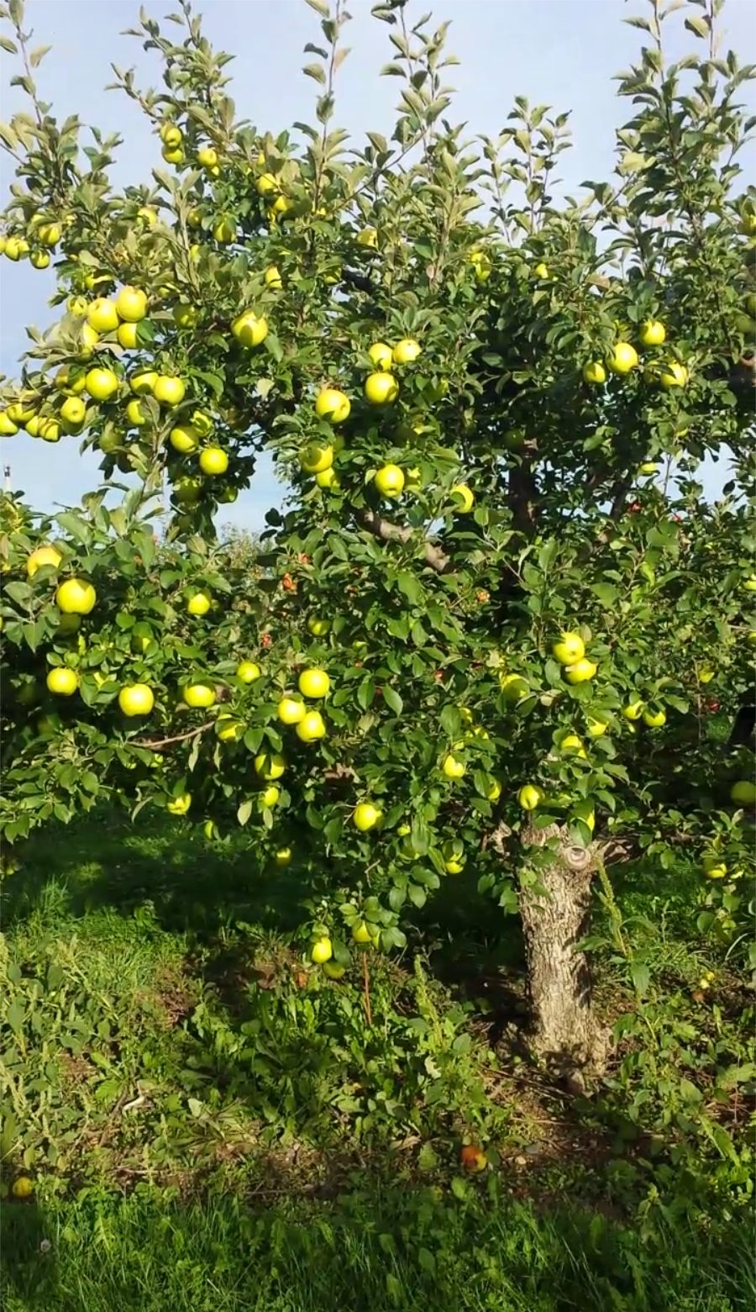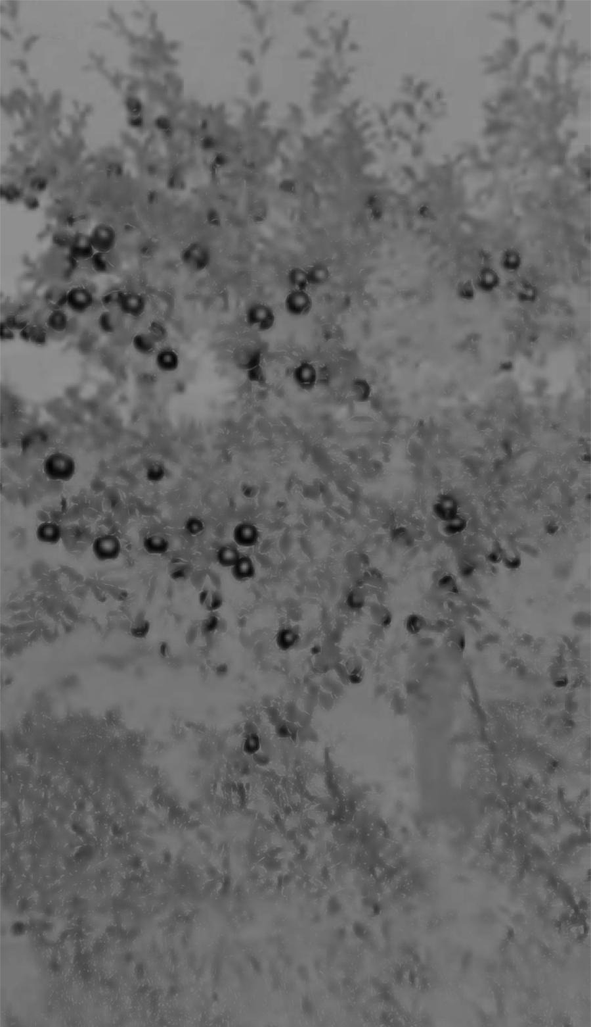

Figure 7: Cb channel pixel value. Green apples have low pixel value range (dark) in this channel. Could easily separate apples from green leaves.

In color defining (4.2.1): use strict threshold (Cb global min value < 10) to get found verdict, and to avoid false result in following steps.

In adaptive threshold calculating (4.2.2-1): Find $min$ and $max$ in Cb channel image, and take threshold $t = min+\left(min-max\right)×0.48$，this adaptive threshold is tuned to be more tolerating, so it is more robust to color shift caused by illumination. All pixels that have Cb value lower than $t$ are marked as green apple pixels.

* 1. **Red:** Using both HSV and RGB color space.

In color defining (4.2.1): use strict threshold (H global max value > 170 and min value < 15).

In adaptive threshold calculating (4.2.2-1):

* For HSV: Find $min$ and $max$ in H channel and take two threshold $t_{H_{max}} = max-\left(max-min\right)×0$, $t_{H_{min}}= min+\left(max-min\right)×0.1$. All pixels that have H value in $\left[0,t_{H_{min}}\right]∪\left[t_{H_{max}},255\right]$ are marked as red apple pixels.
* HSV color space is not precise enough to capture only red apples, so we do a double check in RGB color space.
* For RGB: Calculate R channel percentage $p_{R}$ in three channel values combined. Find $min$ and $max$ in all $p_{R}$. Take adaptive threshold $t_{PR} = min+\left(max-min\right)×0.5$. All pixels have $p_{R}>t_{PR}$ and R channel value > 70 are marked as red apple pixels.

Combine results from HSV and RGB color space. Only pixels that are marked in both spaces are considered as the pixels that make up the red apple.

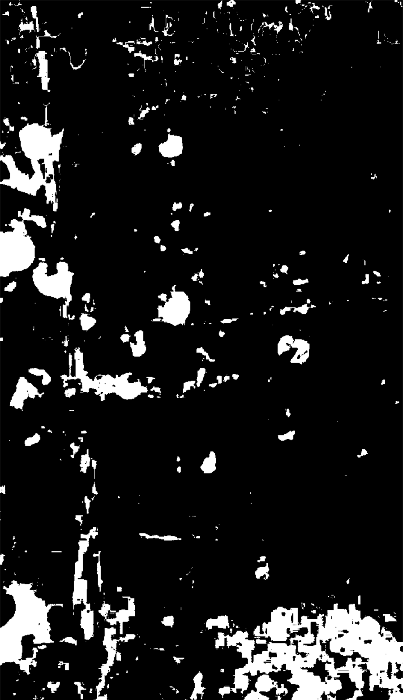 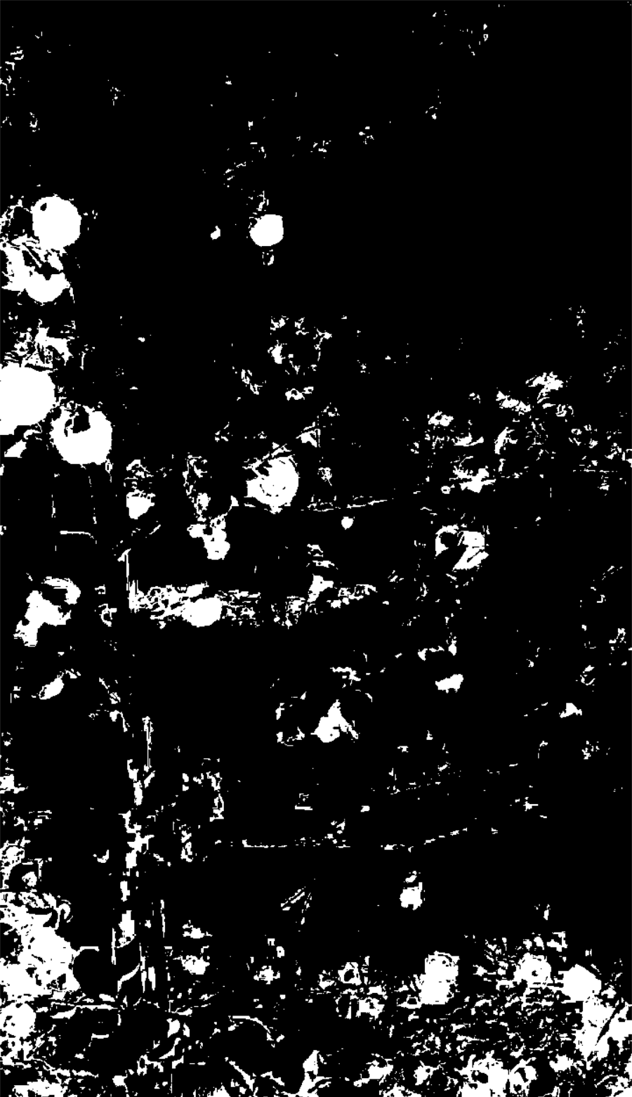 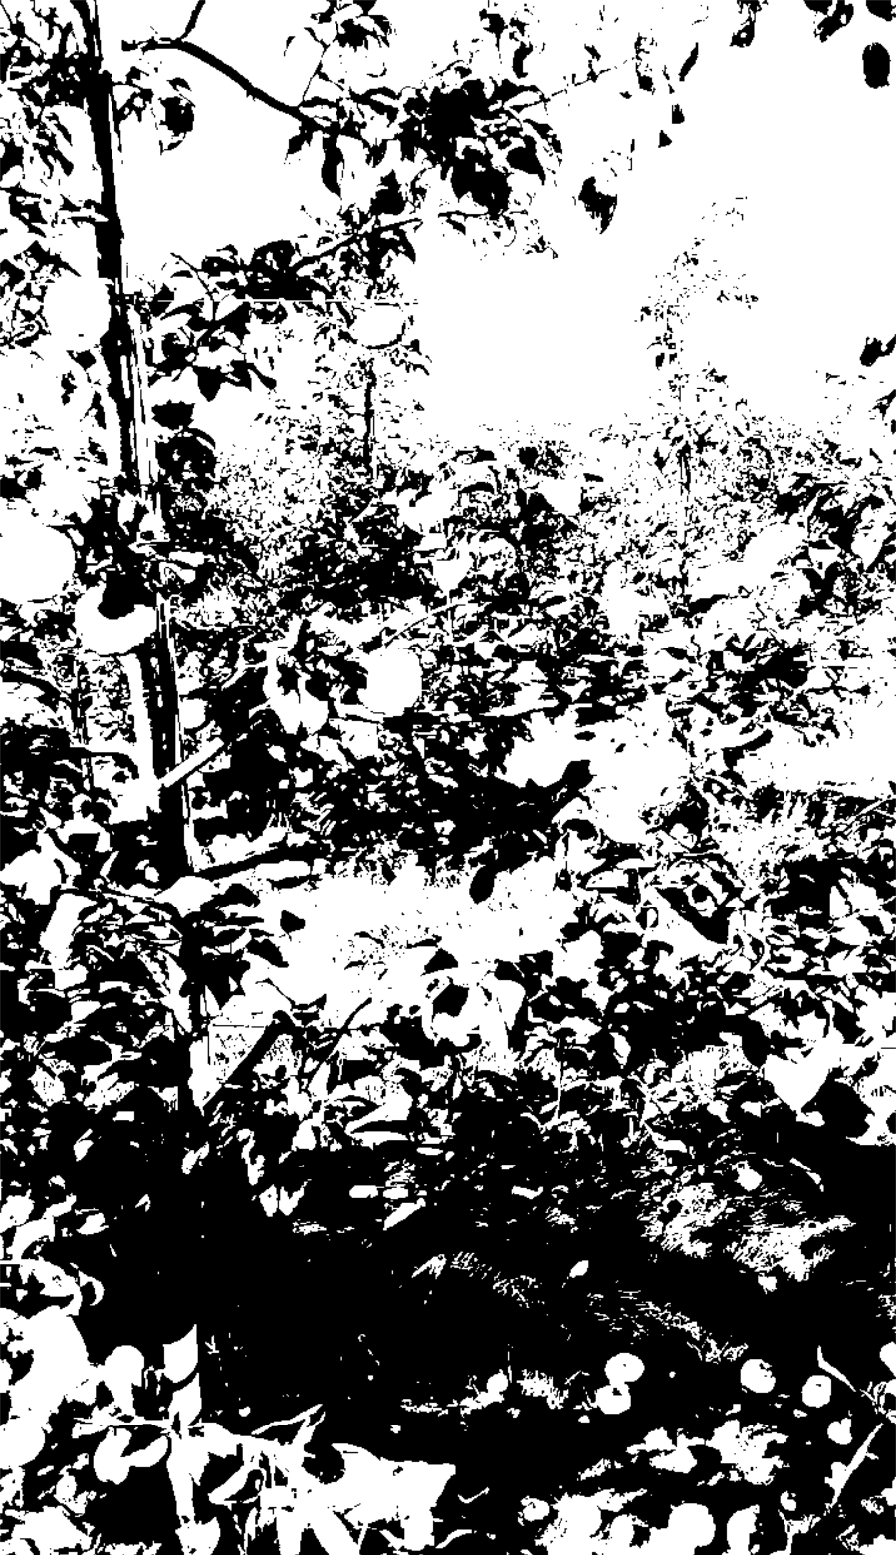

(1) (2) (3)

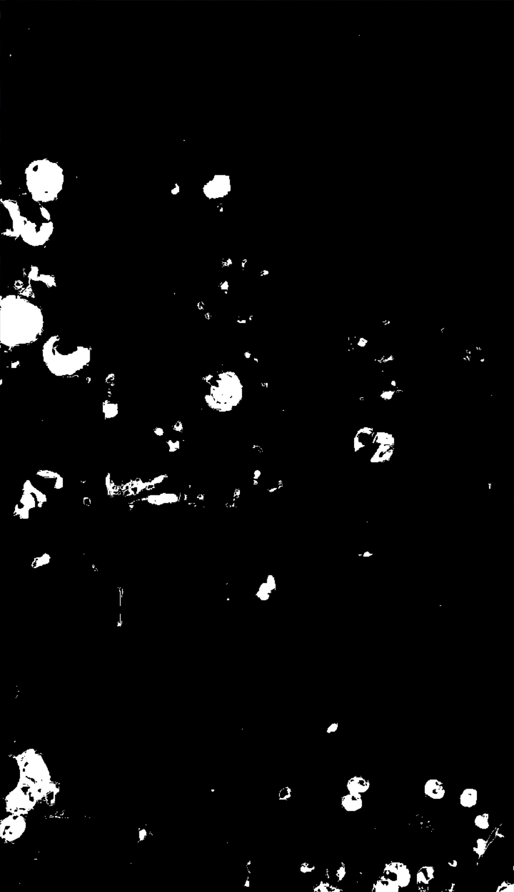 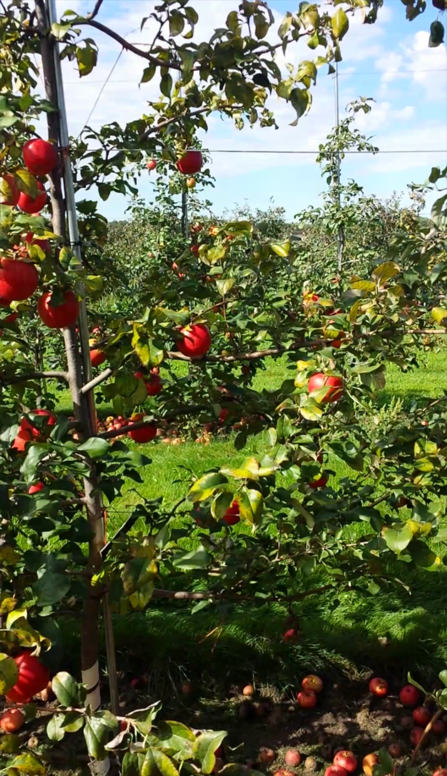

(4) (5)

Figure 8: Red thresholding results. 8-1: HSV thresholding, 8-2: R channel percentage thresholding, 8-3: R channel value thresholding, 8-4: Combined thresholding result, note that branches of the tree is removed, 8-5: Original image.

1. **Canny edge detect**

Before edge detect, we applied median blur with kernel size of 9. Kernel size of 9 is a balance between noise filtering and image detail maintaining for the target dataset.

And for edge detect parameters, we set minVal = 100 and maxVal = 200, L2Gradient = False. These parameters are default for Canny edge detect and we found that it works well. No significant improvement found when we shift the parameters, so we use the default parameters.

1. **Contours detect**

After we detected all contours in the binary picture, we disposed all contours that has perimeter lower than 8. This is a manually adjusted balance between noise filtering and detail maintaining.

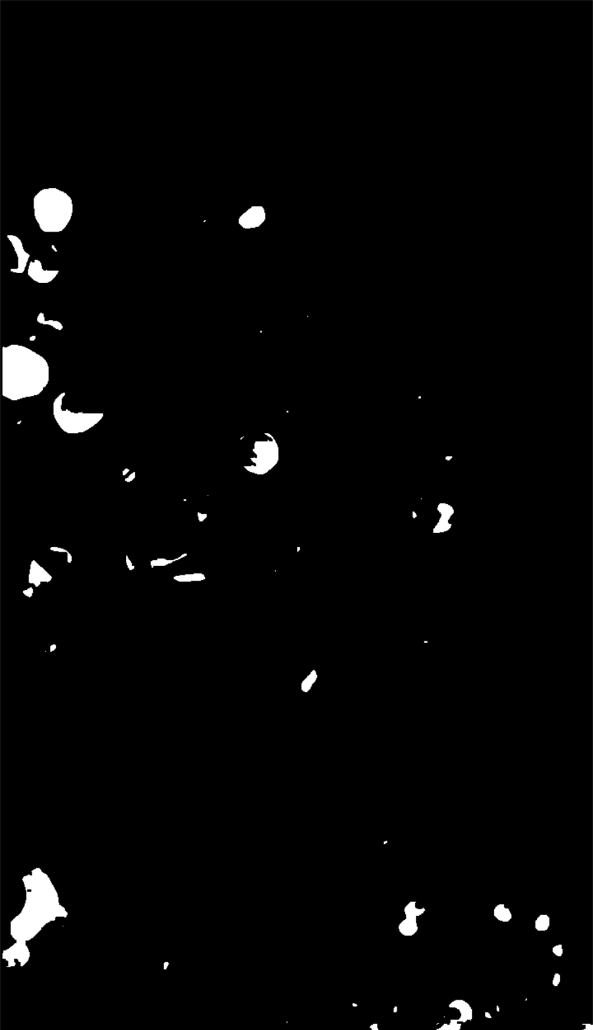 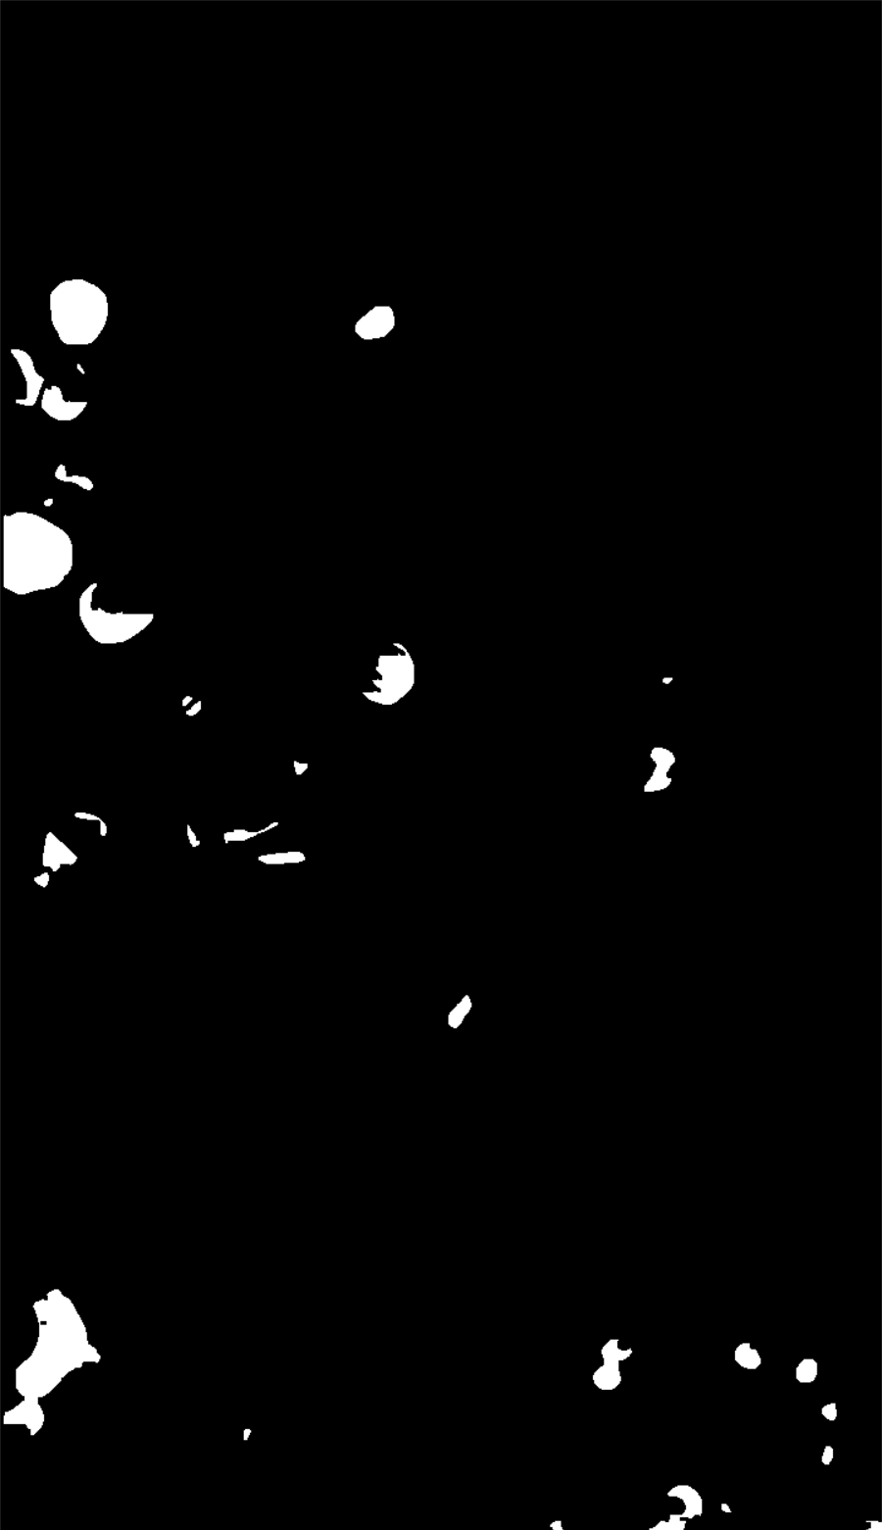

(1) (2)

Figure 9: Before (1) and after (2) contour perimeter filtering.

1. **Morphology operations**

Some morphology operations are added before contour detecting and blob counting. For all the morphology operations we use a minimal sized (2×2) kernel.

The reason we choose minimal sized kernel is that we only need morphology operations to stress the process results from their previous steps, and we still need to keep the details from previous steps.

**6. Results and Evaluation 11(15%)**

Present results; evaluate the proposed approaches (quantitatively and qualitatively) using appropriate metrics; and interpret findings. Make sure you explain how results were obtained and what they mean. Having a method that can detect all apples in all your images does not automatically grant you high marks.

Compare approach A and approach B and discuss their respective capabilities and limitations. For an individual assignment, compare your approach with those in the literature. Use your results to support your statements but also explain this from a theoretical point of view.

提出结果；使用适当的衡量标准对提议的方法进行评价（定量和定性）；并解释结果。确保你解释结果是如何获得的以及它们意味着什么。拥有一种能在所有图像中检测出所有苹果的方法并不能自动给予你高分。

比较方法A和方法B，讨论它们各自的能力和局限性。在个人作业中，将你的方法与文献中的方法进行比较。用你的结果来支持你的陈述，但也要从理论的角度来解释。

7. Conclusions and Future works **(5%)**

Conclude the project. Identify challenges relevant to apple counting (as well as detection and localisation) that have not been fully resolved within the scope of this project. Propose future works to deal with these challenges, e.g. is it possible to employ 3D approaches?

The remaining **10%** of the mark is allocated to report presentation including logical structure and clarity, quality of writing, spelling, grammar, diagrams, figures and tables, clarity of expression and use of English, and accuracy, consistency and completeness of citations and references.

结束该项目。确定与苹果计数（以及检测和定位）有关的、在本项目范围内尚未完全解决的挑战。提出应对这些挑战的未来工作，例如，是否有可能采用三维方法？

其余10%的分数分配给报告表述，包括逻辑结构和清晰度、写作质量、拼写、语法、图表、数字和表格、表达的清晰度和英语的使用，以及引用和参考文献的准确性、一致性和完整性。